**Morgan Bradford**

So my project was going to be a pulse senor that vibrated, waking up the user and helping them pay more attention to what they were doing. But after spending a large chuck of time making no progress due to either bad code, or a broken sensor, or other things possibly beyond my control I gave up and decided to do a project with the only other sensor I could find, a moisture sensor. I also used losant which I was hoping not to do but I didn’t really have time for anything else. But in my free time this summer I might give this another go.

**New Project Description**

**What problem does my new project solve?**

Indoor plants can add new life to a space, increase oxygen in a space which can lead to more productivity and are an inspiration to all, but because of the work that is often required they are replaced with fake plastic plants which are not only unnatural and get thrown in landfills at some point of their life, but they do not offer as many of the benefits that real plants do. Plants are often viewed by younger generation similar to getting a pet because of the responsibilities that come with them, and although plants may make the best roomies they are often go forgotten my project I am going to build a flower pot that is home to a moisture sensor that sends you text updates when you need to water your plants. This will save the lives of plants and allow for more people to grow food at home.

**How is it internet connected?**

The sensor would send you a text message reminding you to water your plant. I am use losant in order to send text messages to the user about their plants.

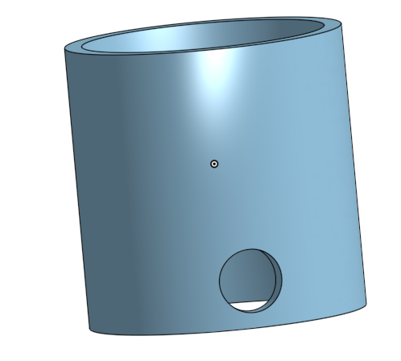**Hardware**

For this project I am going to need:

* A node mcu
* A moisture sensor
* A led
* Some wires
* A 3d printed pot (of my own design)

This will cost nothing because I was gifted everything I used, and 3d printing is free for students.

**Architecture**

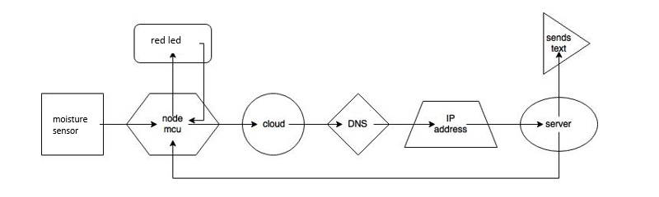

How it sends text:

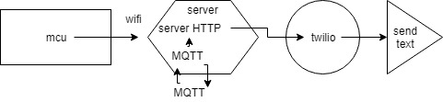

So it reads data from the moisture sensor and in Wi-Fi send that data to the internet where it can be viewed/ where it is published. The cloud is losant, and it will do everything needed to send a text. If the data come in reading that the moisture is two low then it will send a text say that the use needs to water their plants.